User Guide 11 Lodging an application at Land Use Victoria
Purpose of this User Guide
The purpose of this guide is to provide information on how to electronically lodge a SPEAR application. This includes creation of the application lodgment forms, provision of supporting documentation, payment of lodgment fees and electronic lodgment at Land Use Victoria.
Who should read this guide?
Primary audience: Lodging Parties
For information: Applicant Contacts and Land Use Victoria
Introduction
The SPEAR Electronic Lodgment Network allows lodging party subscribers to electronically create and lodge their applications at Land Use Victoria instead of physically attending and providing paper documents. Electronic lodgment through SPEAR is Land Use Victoria’s preferred lodgment method for Subdivision Act applications.
Accepted methods for the payment of lodgment fees to Land Use Victoria are:
- Credit card – You will enter your credit card details on the Westpac Secure Payments screen during lodgment
- Direct Debit (VOTS customer account) – Your account will be automatically debited at the time of lodgment.
An electronic lodging party may request access to an application. This can occur at any stage between the application being accepted at council and the plan being released for lodgment. If the Applicant Contact accepts the request, access to the application will be granted and the requestor will be nominated as the electronic lodging party for the application.
An email notification will be sent to lodging parties when they are nominated. They can view the application immediately but must wait until the plan is certified by council before they can create the application lodgment forms and attach supporting documents.
Once the Applicant Contact has released the application for lodgment, it can be submitted to Land Use Victoria.

NOTE: This guide uses a Section 22 subdivision as an example. The data required to be entered on application lodgment forms will vary for other dealing types, but the process is largely the same.
11.1 Creating an application lodgment form
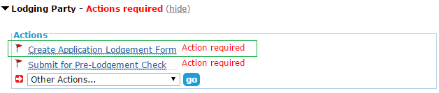
Once the plan has been certified by council, you will be able to create your application lodgment form via the ‘Other Actions…’ drop-down list. If not already completed, this will become a mandatory action once the application is released for lodgment by the Applicant Contact.

Step 1 – Lodged By
Information is prepopulated based on the organisation’s information in SPEAR, however it can be altered if required. The details provided will form the lodging party contact information, which Land Use Victoria will use if they need to contact you.
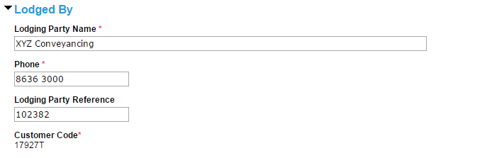

Step 2 – Land
To fulfil the land information requirement, you have the option to add Volume and Folio information. Otherwise, where a title does not exist, the ‘add reference’ option will allow you to provide a General Law, Government Gazette or Common Property reference.
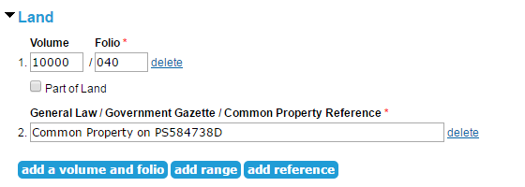

Step 3 – Applicant
To provide applicant information, click ‘add applicant.’ You can add as many applicants as required.
NOTE: If this application is for your own land, select ‘The Lodging Party is the sole Applicant’ and enter your details into the applicant section in SPEAR.
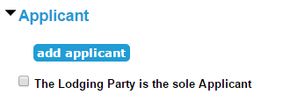

Choose the relevant applicant type and enter the applicant details, including any relevant name change justifications, into the fields provided.
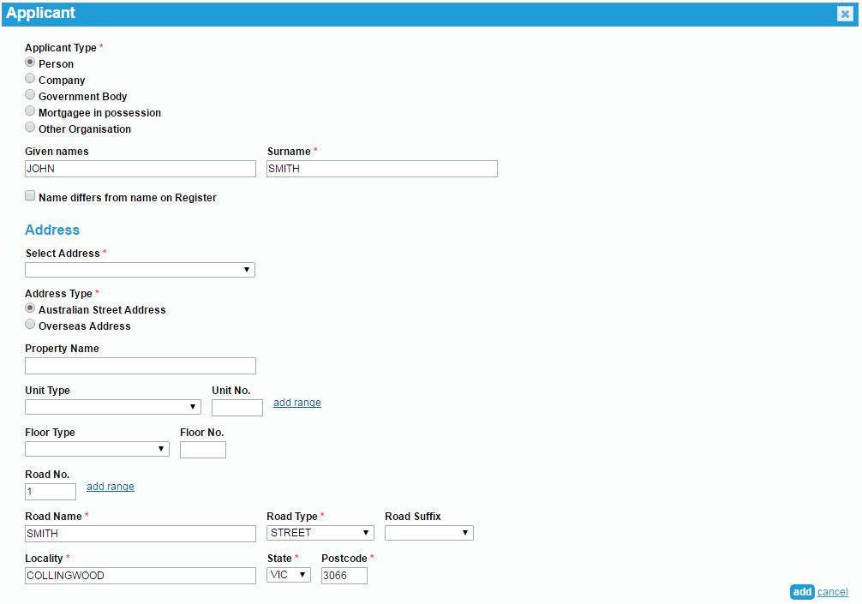

NOTE: You can click ‘save’ at any time to save your progress and return later to complete the application.
After clicking ‘save and close’ you will be prompted to attach evidence of any name changes, if applicable.

11.2 Creating owners corporation forms
After you have created your application lodgment form, you can create owners corporation forms, including the owners corporation rules. If the Applicant Contact has supplied electronic owners corporation data, you will be prompted to create the relevant owners corporation forms. Otherwise, you can create them as required.
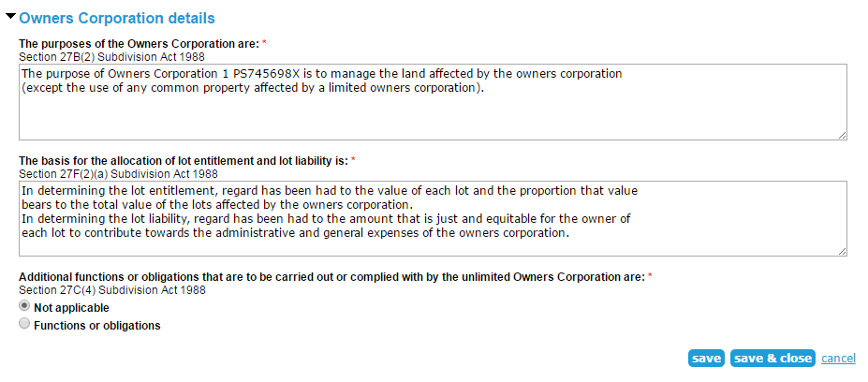
The top sections of the form will be prepopulated. You may be required to enter the owners corporation number, address for service of notices and other owners corporation details.

If creating owners corporation rules, you will be required to attach your rules in PDF format.

11.3 Adding supporting documents
If supporting documents are required, they can be attached via the ‘other actions’ drop-down list.
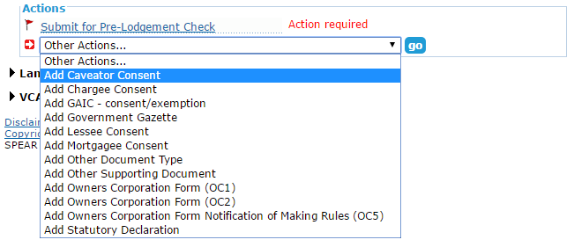

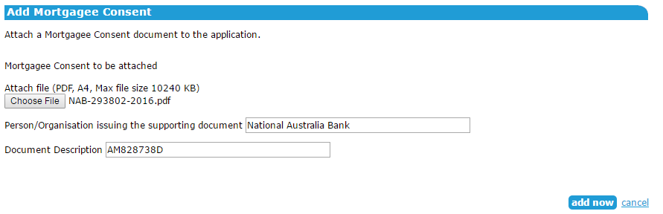
Attach the file and enter identifying information.

11.4 Authenticating documents
Once all required documents have been supplied, they must be authenticated. This includes the Lodgment Instructions, which are automatically generated from the data entered in SPEAR.
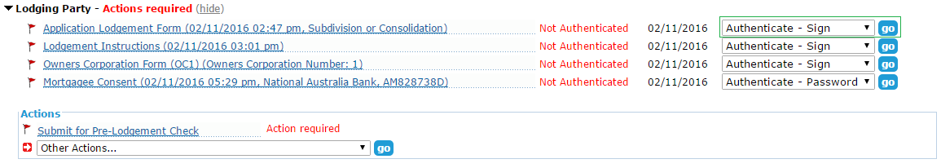
Some documents require password level authentication and can be completed by most users. Application lodgment and owners corporation forms require a digital certificate, which is typically held by a solicitor or licensed conveyancer.

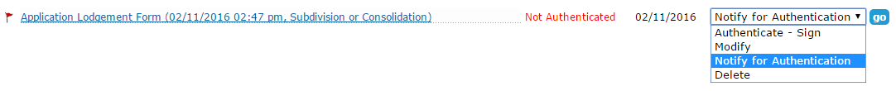
If you do not have the required access level, you can request someone else in your organisation to authenticate a document.

11.5 Submitting for pre-lodgment check
Once you have attached and authenticated the required documents, click ‘Submit for Pre-Lodgement Check’.
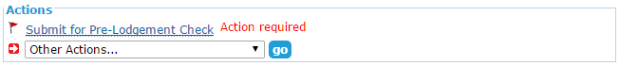

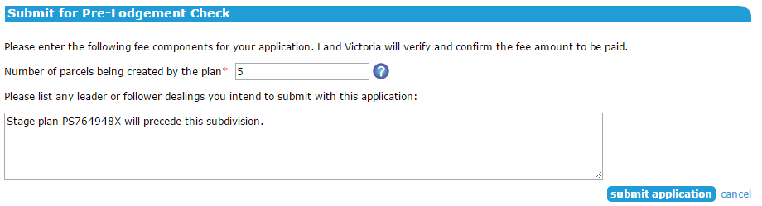
Depending on the application type, you may be required to enter the number of parcels being created by the plan or the purpose/s of the plan. You can also provide details of any leader or follower dealings that will be lodged with the plan.

Once the application is submitted, Land Use Victoria will check it to ensure it is fit to be lodged. You will be notified by SPEAR when the application is ready to be lodged. A fee estimate will be included in the notification email.

11.6 Pay and lodge
Click ‘Pay and Lodge’ to display the lodgment fee due.


Select your preferred payment method and click ‘pay and lodge’ to submit the lodgment. If you selected to pay by credit card, you will be directed to Westpac Secure Payments to enter your credit card details. A receipt will be available in SPEAR following successful payment.
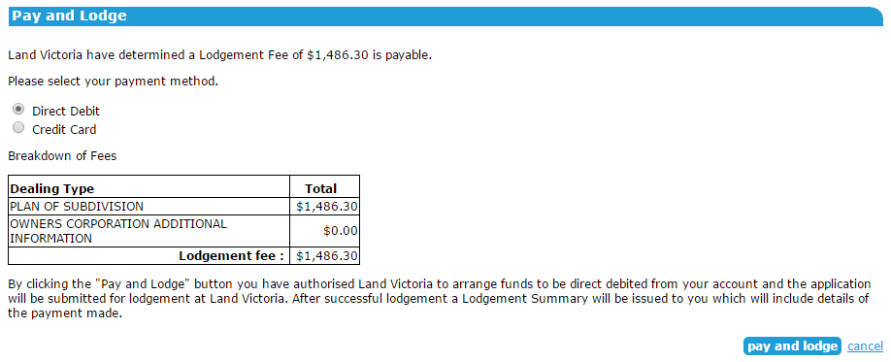

Once the application has been lodged, the status in SPEAR will change to ‘Lodged at Land Victoria’ and you will receive an email notification containing the lodgment summary.

11.7 Land Use Victoria requisitions
If Land Use Victoria requires changes to your application, you will be notified by SPEAR. You will then be able to add, amend or delete any supporting documents as required, or direct Land Use Victoria to make minor amendments to the application lodgment and owners corporation forms.
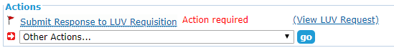

Ensure you have made changes to supporting documents as required before you enter your response to Land Use Victoria. If no document changes are required, simply detail your direction to Land Use Victoria.
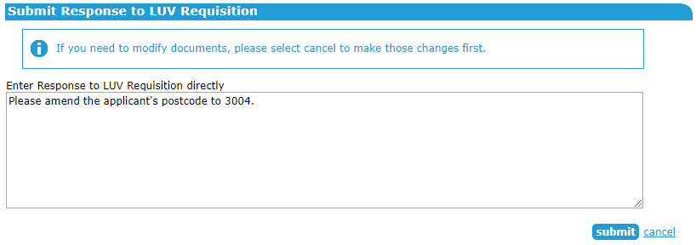

Need more information?
Further information on this topic can be found by:
- Visiting the SPEAR website www.spear.land.vic.gov.au/SPEAR
- Contacting the SPEAR Service Desk on 9194 0612 or email spear.info@delwp.vic.gov.au
- Selecting the Help link in the relevant area of the SPEAR system.
- Referring to:
- User Guide 9 – Releasing for lodgment at Land Use Victoria
- User Guide 34 – Testing your digital certificate
- User Guide 42 – User Authentication Levels and Document Authentication in SPEAR

